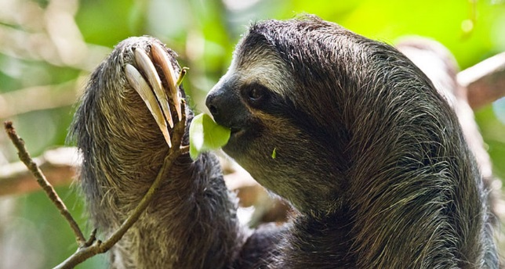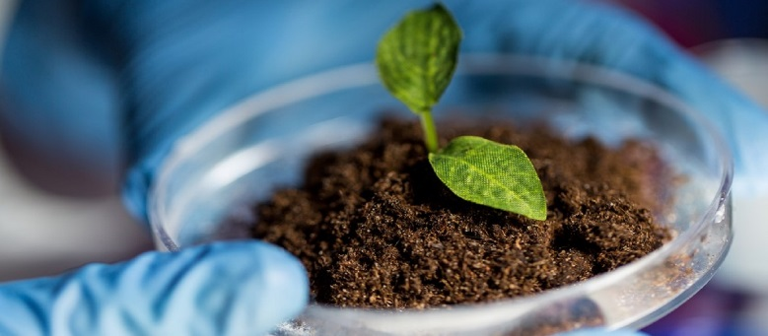BIOLOGY

**Biology Textbook**

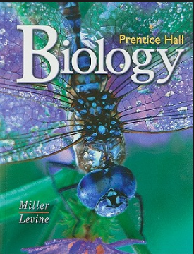

Each student will be issued a textbook which will be used for most homework assignments.

Textbooks DO NOT NEED to come to class (keep them at home to study and do homework). Bring these back at the end of the year.

**Redeeming Biology Bucks**

* **5 bucks=Late homework turn in (no penalty)**
* **9 weeks Extra Credit Point**
* **5 bucks=exchange for 1 Canes Cash**

**Promoting Literacy**

*A Short History of Nearly Everything* by Bill Bryson

**Semester Grading Component (1st and 2nd semester)**

60%-Summative Assessments (Tests and Lab with Formal Lab Write-ups)

30%-Formative Assessments (Quizzes, papers, etc.)

10%- Daily Work (Classwork and homework)

**Georgia Biology Milestone TEST**

**20% of Final Average**

**Final Grade**

40% 1st Semester Grade

40% 2nd Semester Grade

20% Biology Milestone Score

**Earning Biology Bucks**

* **Participating in Class Discussions**
* **Performing a Lab skill exceptionally well**
* **Impressive score on a formative assessment**
* **Teacher Discretion**

**Sequencing**

**1st Semester**

Defining Life

Chemistry of Life

Evolution

Ecology

Biology in a Bottle

Kingdoms

**2nd Semester**

Cycling Carbon

Cells

Cell Transport

Cell Reproduction

Viruses

Genetics

**Homework**

* Assigned Wednesday
* Due the next Wednesday
* Need to turn it in late? 5 Biology Bucks will let you turn it in by Friday of the week it was due (a 2 day extension).

**Course Description**

This course explores life! Biology, quite literally, means the “study of life.” We will use microscopes to investigate and explore properties of life as well as different microscopic behaviors and phenomena. We also dive into topics such as genetics, ecology, and evolution.

**Class Rules:**

* Be safe by following safety contract rules.
* Respect the space and property of others.
* Treat your table and equipment with respect
* Keep your area clean by throwing trash away in the trash bin (not the sink).
* No food or unseal-able drinks
* Follow Instructions